打“★”号条款为实质性条款，若有任何一条负偏离或不满足则导致投标无效。 打“▲”号条款为重要技术参数，若有部分“▲”条款未响应或不满足，将导致其响应性评审加重扣分，但不作为无 效投标条款。

附件：采购设备清单及技术参数要求
Attachment: List of purchased equipment and technical parameters/requirements
一、 总体性能及技术要求
I. Overall Performance and Technical Requirements
1. 实验室专用实验台柜设备的材料及其配套件性能及技术应满足本“用户需求书”要求。
1. The performance and technology of the materials, parts and components of the special experiment bench and cabinet for laboratory shall comply with the requirements of the “User’s Demand Instructions”.
2. 实验室设施及其配套水电安装位置应满足业主提供的有关文件和设计图要求。
2. The installation locations of facilities and supporting water and electricity for laboratory shall be in line with the relevant documents and design drawings of the Employer.
实验室设施及配套水电安装施工应符合以下标准的要求：
The requirements of the following standards shall be met in terms of the installation and construction of facilities and supporting water and electricity for laboratory:
《人造板及饰面人造板理化性能试验方法》GBT17657-2013
Test methods of evaluating the properties of wood-based panels and surface decorated wood-based panels
《实验室家具通用技术条件》GB 24820-2009；
General Technical Requirements for Laboratory Furniture (GB 24820-2009);
《建筑给水排水设计规范》 (GB 50015-2003)；
Code for Design of Building Water Supply and Drainage (GB 50015-2003);
《民用建筑电气设计规范》(JGJ16-2008)；
Code for Electrical Design of Civil Buildings (JGJ16-2008);
《民用建筑电线电缆防火设计规程》(DGJ08-93-2002)；
Code for Fireproofing Design of Wires and Cables used in Civil Buildings (DGJ08-93-2002);
《建筑设计防火规范》(GB 50016-2014)；
Code for Fire Protection Design of Buildings (GB 50016-2014);
3. ★实验室专用实验台柜设备其硬件的结构强度和性能特征要满足本“用户需求书”中《实验室等级钢制家具检测方法和性能指标》的要求：
3. The structural strength and performance characteristics of the hardware of the special experiment bench and cabinet for laboratory shall meet the requirements of the Test Methods and Performance Indicators of Steel Laboratory Furniture in the “User’s Demand Instructions”:
3.1. 实验室专用钢制实验台柜应能承受以下最大荷重而不变形或影响使用：
3.1. The special steel experiment bench and cabinet for laboratory shall bear the following maximum load without deformation or its use affected:
3.1.1. 落地式底柜柜体荷重性能检测：907公斤(约2000磅)；
3.1.1. Tested load performance of floor base cabinet: 907kg (approx. 2,000 lbs);
3.1.2. 落地式底柜柜体集中荷重性能检测：90公斤(约200磅)；
3.1.2.Tested concentrated load performance of floor base cabinet: 90kg (approx. 200 lbs);
3.1.3 框架式底座框架荷重性能检测：272公斤(约600磅)；
3.1.3Tested load performance of frame of frame base: 272kg (approx. 600 lbs);
3.1.4. 抽屉静态荷重性能检测：68公斤(约150磅)；
3.1.4. Tested static load performance of drawer: 68kg (approx. 150 lbs);
3.1.5. 底柜层板及试剂架层板荷重性能检测：18.14公斤/平方英尺(约40磅/平方英尺)，根据层板面积最高至90公斤(约200磅)。
3.1.5. Tested load performance of laminate of base cabinet and reagent rack: 18.14kg/ft² (approx. 40 lbs/ft²); maximum (based on laminate area): 90kg (approx. 200 lbs).
4. ▲实验室等级钢制实验台柜钢材表面处理要求(所有钢制柜体、框架及支架依本规定办理)：
4. Requirements of surface treatment of laboratory-grade steel experiment bench and cabinet (including all steel cabinet, frame and support):
4.1. 采用环氧树脂粉末静电喷涂工艺处理，涂层厚度不小于75微米，颜色可根据家具制造商的标准色卡由用户同意选择。
4.1. The electrostatic spraying process with epoxy resin powder shall be applied, The coating thickness is not less than 75 microns， and the color can be selected based on the standard pantone of furniture manufacturer under the approval of user.
4.2. 所有部件不得于安装现场焊接加工，以避免破坏表面环氧树脂涂层。
4.2. All components shall not be welded on the installation site to avoid damage to surface epoxy resin coating.
4.3 除有特别说明者外，所有柜体内组装用螺丝均应为不锈钢材质螺丝，不得采用有尖头的自攻螺丝以避免接触伤害，所有钣金部件不得于安装现场焊接加工，以避免破坏表面环氧树脂涂层。
4.3 Unless otherwise stated, the screw in cabinet for assembly shall be made of stainless steel, and the sharp-pointed self-tapping screw shall not be used, so as to avoid contact injury; all sheet metal components shall not be welded on the installation site to avoid damage to surface epoxy resin coating.

二﹑ 主要设备材料、结构及技术要求：
II. Main Equipment Materials, Structures and Technical Requirements:
（一）全钢结构实验台：
(I) All-steel experiment bench:
所有中央台、边台、仪器台（仪器室）台面不小于16mm厚，操作面前缘上边经圆滑处理，美观且光滑不伤手。
The surface board of all central tables, side tables and instrument tables (instrument room) shall be no less than 13mm in thickness; the front upper edge of operating surface shall be smoothed to avoid hurting hand.
1） 实验台台面
1) Table board

- ▲采用不小于16mm厚由30%热固树脂和70%树脂纤维高温高压下固化成型，三维基材结构不弯曲不变形。不采用以牛皮纸为基材，结构紧固致密，能抗冲击。表面经EBC电子束固化技术处理，确保表面致密无孔耐腐蚀，易清洁、消毒和维护。
1. The board, thickness of 13mm, shall be made of 30 % thermosetting resin and 70 % resin fiber under high temperature and high pressure with three- dimensional base material structure , which is not bent or deformed. It shall not use kraft paper as the base material and has a tight and compact structure and can resist impact. The surface is treated by EBC (electron beam curing) technology to ensure that the surface is compact, non-porous and corrosion - resistant, and easy to clean, disinfect and maintain.
- 并符合以下技术参数：
2. Shall meet the following technical parameters:
- ▲台面须提供有CMA认证的检测机构所出具的材料检测报告，检测标准参照GB/T17657-2013，测试结果为5级。
应至少包含有：其中至少包含硫酸98%，硝酸65%，磷酸85%，盐酸37%，氢氧化钠40%，77%硫酸+65%硝酸，二氯甲烷，甲醇，丙酮等化学物，测试结果为5级
3.The table top shall provide the report of the National Building Materials Testing Center ( the test report of cover glass shall be provided ), and the test standard shall refer to GB / T 17657 - 2013. Test results: Level 5
Contains at least 98% sulfuric acid, 65% nitric acid, 85% phosphoric acid, 37% hydrochloric acid, 40% sodium hydroxide, 77% sulfuric acid +65% nitric acid, dichloromethane, methanol, acetone and other chemicals, test results of 5
- ▲台面须提供SEFA3.0的测试报告，至少47项试剂达到0级,无明显变化
4. The table top shall provide SEFA 3.0 test report At least 47 reagents reached grade 0 without significant change
- ▲台面须国家权威检测机构出具的甲醛报告, 要求采用GB17657-2013 标准，结果为：未检出，即小于＜0.01mg/m³，( 检测报告复印件加盖公章)。
5. Formaldehyde test report shall be provided. The test standard shall refer to GB17657-2013. Results: no detection, that is, less than < 0.01mg/m3, (copy of test report with official seal).
- 绿色环保，需提供SGS出具的PEFC和FSC证书
6. For Green and environmental protection, certificates issued by a qualified party shall be provided
- 台面需提供由SGS出具的EBC技术的使用证明
7. The table top shall provide the certificate of EBC technology issued by SGS
- 抗菌性能：依据ISO 22196:2011检测标准检测，大肠杆菌测试结果抗菌活性值≥6.0，金黄色葡萄球菌测试结果抗菌活性值≥5.4，肺炎克雷伯氏菌测试结果抗菌活性值≥5.7，粪链球菌测试结果抗菌活性值≥2.6，肠沙门氏菌肠亚种测试结果抗菌活性值≥4.1。
8. Antibacterial properties:According to ISO 22196:2011 test standard, the antibacterial activity value of Escherichia coli test results was ≥6.0, the antibacterial activity value of Staphylococcus aureus test results was ≥5.4, the antibacterial activity value of Klebsiella pneumoniae test results was ≥5.7, and the antibacterial activity value of Streptococcus faecalis test results was ≥2.6.The antibacterial activity value of Salmonella enterica intestinal subspecies test was ≥4.1.
- ▲为保证实验室内部环境空气质量，要求台面板需提供Green guard Gold认证证书（绿色卫士金级认证证书），报告中要求其中TVOC挥发性有机物测试标准最大允许预测浓度为0.22mg/m³.
9.In order to ensure the indoor air quality of the laboratory, it is required that Greenguide Gold certificate shall be provided. The report requires that the maximum allowable predicted concentration of TVOC (volatile organic compounds) test standard is 0.22 mg / m3.

10. ▲提供原产地相关证明材料（格式不限）
11. *投标人需提供满足以上技术参数的产品售后服务承诺函，要求产品售后服务承诺函具有法律效力，在承诺函里面要求明确如下条款；
A． 有限保修期为10年，并明确有限保修条件；
B． 损害赔偿限制条款；
C． 排除条款
D． 免责声明
E． 适用法律和有管辖权的法院
F． 法律行动
投标人承诺在项目中标之后，合同签订之前，需另外提供包含以上内容的，加盖厂家公章的售后服务承诺函给招标人。
12、 台面安装要求；台面应保持水平，拼合台面应保持在一个平面内。台面与柜体间应连接稳固，台面不能脱落或跷起。
C. Requirements for table board installation: The table board shall be horizontal, and the pieced table boards shall be kept in one plane. The table board shall be securely connected to cabinet, and be free of stripping and tilting.
13、 ▲实验台承重≥200Kg/m²,仪器台承重≥300Kg/m²。
13. The load bearing shall be ≥200Kg/m² for experiment bench and ≥300Kg/m² for instrument table.
2） 门板
2) Door plank
- ▲采用1.2mm一级冷轧钢板（SPCCT）或同等级别钢板经CNC机压成形、焊接制作，表面经环氧树脂粉体涂装处理（涂装厚度为75μm）。柜门为双包结构，内附防噪填充。每个包层都是先喷涂再包合，不会因局部的破损而导致内部的损伤。
The 1.2mm first-grade cold-rolled steel sheet (SPCCT) or the steel plate of the same grade shall be used, shaped by CNC machine, welded and subject to surface treatment by coating with epoxy resin powder (with a coating thickness of 75μm). The cabinet door shall be double-packed with noise reduction filling. Each covering shall be sprayed and then wrapped to avoid internal damages due to partial breakage.
4） 抽屉
4) Drawer
- ▲采用1.2mm一级冷轧钢板（SPCCT）或同等级别钢板经CNC机压成形、焊接制作，表面经环氧树脂粉体涂装处理（涂装厚度为75μm）。
The 1.2mm first-grade cold-rolled steel sheet (SPCCT) or the steel plate of the same grade shall be used, shaped by CNC machine, welded and subject to surface treatment by coating with epoxy resin powder (with a coating thickness of 75μm).
5） 活动层板
5) Movable laminate
采用1.2mm一级冷轧钢板（SPCCT）或同等级别钢板经CNC机压成形、焊接制作，表面经环氧树脂粉体涂装处理（涂装厚度为75μm）。层板支撑扣采用1.2mm厚304#不锈钢制作，层板可以上下调节。
The 1.2mm first-grade cold-rolled steel sheet (SPCCT) or the steel plate of the same grade shall be used, shaped by CNC machine, welded and subject to surface treatment by coating with epoxy resin powder (with a coating thickness of 75μm). The support buckle of laminate shall be made of 1.2mm thick 304# stainless steel, and the laminate shall be available for upward and downward adjustment.
6） 活动维修背板
6) Movable backboard for repair
采用可拆装式设计，以方便管线安装维护。
It shall be removable for easy installation and maintenance of pipeline.
7） 踢脚板
7) Skirting board
▲采用1.8mm一级冷轧钢板（SPCCT）或同等级别钢板经CNC机压成形、焊接制作，表面经环氧树脂粉体涂装处理（涂装厚度为75μm）。
The 1.8mm first-grade cold-rolled steel sheet (SPCCT) or the steel plate of the same grade shall be used, shaped by CNC machine, welded and subject to surface treatment by coating with epoxy resin powder (with a coating thickness of 75μm).
- 底柜五金及配件
1. Hardware and accessories of base cabinet
1. 滑轨：
1. Sliding rail:
1. 采用三节式滚珠滑轨，表面经防蚀处理，具止落装置，防止抽屉意外滑离柜体，但可轻易用手将抽屉全部拆出。滑轨需通过有关标准（列出），50000次抽拉试验。
1. The three-section ball-bearing slide shall be used with surface subject to anti-corrosive treatment, and be provided with a falling stop device to prevent drawer from sliding away from cabinet by accident while the drawer can be easily fully removed by hand. The sliding rail shall be subject to the pulling test for 50,000 times in accordance with the (listed) relevant standards.
2. 抽屉导轨为冷轧钢板模具冲压成型制作，重负荷包夹式滑轨，尼龙滚珠，自闭结构设计。运动负重≥25kg（≥100000次），抽屉内表面均设有防撞垫片。
2. The guide rail shall be manufactured by punch forming of cold-rolled steel sheet mould, with heavy load clip-on sliding rail, nylon ball and self-closing structure. The motion load shall be ≥25kg (≥100,000 times), and the internal surface of drawer shall be provided with anti-collision pad.
3. 合页或铰链：
3. Hinge:
1. 采用优质合页或铰链，铰链应有三度空间微调位置功能，以调整门板的间隙。需通过有关标准（列出）,50000次拉开测试。每片门板至少配置两只合页或铰链。
1. The high-quality hinge shall be adopted, and the hinge shall have the function of three-dimensional fine adjustment of position, so as to adjust the gap between door planks. The hinge shall be subject to the open test for 50,000 times in accordance with the (listed) relevant standards. Each door plank shall be provided with two hinges.
合页或铰链开启角度大于180度，304不锈钢，5节式。通过相关认证、并提供相关的认证文件。
The hinge shall have an opening angle greater than 180°, be made of 304 stainless steel and be of 5-section. And it shall pass related certification and provide relevant certification documents.
2. 把手：编号316不锈钢把手，抽屉宽度超过600mm及以上时应配置两只把手。
2. Handle: The 316 stainless steel handle shall be employed, and two handles shall be equipped when the width of drawer exceeds 600mm and above.
9） 其它
9) Miscellaneous
1. 柜体为落地式结构，一般高度(含调整脚及台面厚度)为850mm；
1. The cabinet shall be a floor cabinet with a general height of 850mm (including the thickness of adjustable feet and table board);
2. 所有底柜双开门间无中央垂直支柱阻挡。柜体内有层板上下调节孔，每个底柜设活动层板一只，层板宽度与底柜内宽度相当，不得于两侧有各超过3mm的间隙。
2. There shall be no central vertical pillar between the double doors of base cabinet. The cabinet shall be provided with a hole for the upward and downward adjustment of laminate; each base cabinet shall be installed with one movable laminate; the width of laminate shall be equivalent to the width of base cabinet, and a gap exceeding 3mm on both sides is not allowed.
3. 服务通道：中央桌背对背框架中间空档及靠边桌框架与墙面中间空档有一个服务通道距离，用来布设电、水、气管路，隐藏设计。
3. Service channel: The space between the back-to-back frames of central tables and between the frame of side table and wall is available for service channel, which shall be hidden and used to lay out pipelines for electricity, water and gas.
4. 所有钣金的表面接缝均应满焊，焊接处均应打磨平整以保持为连续的平滑表面
4. The surface joints of sheet metal shall be fully welded, and the welds shall be ground to maintain a continuous smooth surface.
5. ▲所有部件不得于安装现场焊接加工，以避免破坏表面环氧树脂涂层。
5. All components shall not be welded on the installation site to avoid damage to surface epoxy resin coating.
6. 座位空间：依据图纸及相关说明所示，于实验台框架间配置座位空间。
6. Seat space: The seat space shall be provided between the frames of experiment bench as indicated in drawings and relevant instructions.
7. 装饰封板：依图纸说明所示，柜体内部后方，背对背柜体中间空档外侧及靠边实验台柜体与墙面中间空档外侧，须使用钢制装饰封板遮盖，封板的颜色及表面处理应与柜体相同；所有装饰封板为可拆装式设计，其组装螺丝应以孔塞遮蔽不可外露。
7. Decorative sealing plate: For the inner rear part of cabinet, and for the outside of the space between the back-to-back cabinets and between the cabinet of side experiment bench and wall, the steel decorative sealing plate shall be used for covering, of which the color and surface treatment shall comply with that of cabinet. All sealing plates shall be removable and their screws for assembly shall be covered with plug.
10） 试剂架
10) Reagent rack
1. 独特的菱形德式试剂架，支柱采用厚1.0mm一级冷轧钢板（SPCCT）经CNC机压成形、焊接制作，表面经环氧树脂粉体涂装处理（涂装厚度为75μm）。
1. The rhombic German-style reagent rack shall be adopted, of which the support shall be made of 1.0mm thick first-grade cold-rolled steel sheet (SPCCT) which is shaped by CNC machine, welded and subject to surface treatment by coating with epoxy resin powder (with a coating thickness of 75μm).
2. 固定片、调节架支撑翼、后挡板：采用优质1.0mm厚冷轧钢板冲折制作，表面经环氧树脂粉体烤漆防腐蚀处理，其厚度为75μm。
2. Fixed piece, braced wing of adjusting bracket and rear baffle: The high-quality 1.0mm thick cold-rolled steel sheet shall be used, and then be punched and bent, and subject to anti-corrosion surface treatment with epoxy resin powder paint with a thickness of 75μm.
3. 采用台面安装式设计，以方便配置增减拆装。
3. The table board design for installation shall be employed to facilitate addition, reduction, disassembly and assembly.
4. 依图纸说明所示，按需求配置单面型或双面型两种式样以方便中央台及边台使用试剂架。
4. Based on what indicated in drawings, the single- or double-side reagent rack shall be equipped as required for the easy use for central table and side table.
5. 试剂架立柱具整排挂孔供活动层板悬挂用，层板上下调节间距每格应小于25mm(约1英吋)。
5. The column of reagent rack shall have a row of hanging holes forhanging movable laminate, and the spacing for upward and downward adjustment of laminate shall be less than 25mm (approx. 1 inch) for each grid.
6. 试剂架层板：8mm厚钢化玻璃，分上下2层，高低可调活动式，层板外缘采用Φ12mm 编号SUS304不锈钢材质护栏。
6. Laminate of reagent rack: It shall be made of 8mm thick tempered glass, suitable for height adjustment and provided in 2 layers, and shall be provided with Φ12mm SUS304 stainless steel guardrail on the outer edge.
7. 试剂架立柱内侧应按要求配置插座安装孔，立柱内夹层应有足够空间供插座配线隐藏铺设。
7. The inner side of the column of reagent rack shall be arranged with a hole for mounting socket as required, and there shall be enough space for the interlayer inside the column for the hidden laying of socket wire.
11） 功能柱
11) Functional column
1. 采用厚1.0mm一级冷轧钢板（SPCCT）经CNC机压成形、焊接制作，表面经环氧树脂粉体涂烧防蚀处理，其厚度为75μm。
1. The 1.0mm thick first-grade cold-rolled steel sheet (SPCCT) shall be used, shaped by CNC machine, welded and subject to anti-corrosion surface treatment by coating with epoxy resin powder with a thickness of 75μm.
2. 功能立柱应为本体与面板组合可拆装式设计，其组装螺丝应以孔塞遮蔽不可外露。
2. The functional column shall be a detachable combination of column and panel, of which the screws for assembly shall be covered with plug.
3. 功能立柱应有足够的内部空间及必要的开孔，以便通过及容纳实验台需要的公用系统管线及相关配件，管线槽内的强电/弱电/水/气等应具各自独立的区隔。
3. The functional column shall be designed with adequate inner space and necessary holes to accommodate pipelines and relevant parts of the utility system required for experiment bench. Separate partition in pipeline slot shall be enabled for ELE/ELV/water/gas, etc.
4. 功能立柱尺寸有二种，分别为400×150，200×100mm，高度根据现场情况从天花接至实验台台面(具体配置与有关参数，应参照相关招标文件提供的设备清单、技术条款和图纸所示)。
4. The functional column shall be provided in two sizes which are 400×150 and 200×100mm, and shall connect the ceiling and the top of experiment bench according to the practical situation on site (the specific configuration and relevant parameters shall comply with the equipment list, technical terms and drawings from the bidding document concerned).
实验室家具配件
III. Fittings of Laboratory Furniture
立式三口鹅颈水龙头：
Vertical three-outlet gooseneck faucet:
1. 台面安装型，以固定座锁定于水槽后台面上开孔；
1. It shall be installed on table top, with its fixed seat locking to the opening on the table board behind sink;
2. 采用黄铜合金材质管体，表面经环氧树酯粉末静电喷涂处理；
2. It shall be the brass alloy tube and have surface treated by electrostatic spraying with epoxy resin powder;
3. 冷水专用，具各自独立调节三阀体，三出水口设计；
3. It shall be specially designed for cold water, with three separate adjustable valves and with three outlets;
4. 上方一只鹅颈式出水口可360°旋转，下方两只固定式出水口左右距离250mm及以上；
4. The upper gooseneck outlet shall be capable of 360° rotation, and the lower two fixed outlets shall be 250mm and above from each other;
5. 阀芯采用180°；阀芯密封，在动态压力为0.3MPa±0.02 MPa的水压下，不带附件，流量≥0.20L/s；
5. The valve element shall be capable of 180° rotation; In the dynamic pressure of 0.3mpa ± 0.02mpa water pressure, without accessories, flow ≥0.20L/s;
6. 具可拆式尖嘴型锯齿多节状出水口，以确保软管衔接时的紧密；另具气泡缓压式出水口可供选配；符合DIN12898标准及符合AS/NZS3718标准，可拆卸，材质可选铜制或PP，带防溅滤水器。
6. It shall be equipped with detachable sharp-nose serrated multi-section outlets to ensure a tight connection of hose, and provided with alternative bubble pressure-relief outlet; According to DIN12898 and AS/NZS3718, removable, made of copper or PP, with splash proof filter.
立式单口鹅颈冷热水龙头：
Vertical single-outlet gooseneck hot and cold water faucet:
7. 台面安装型，以固定座锁定于水槽后台面上开孔；
7. It shall be installed on table top, with its fixed seat locking to the opening on the table board behind sink;
8. 采用黄铜合金材质管体，表面经环氧树酯粉末静电喷涂处理；
8. It shall be the brass alloy tube and have surface treated by electrostatic spraying with epoxy resin powder;
9. 冷热混合用，具冷、热水独立调节双阀体，单出水口设计；
9. It shall be designed for both hot and cold water, with two adjustable valves separately for cold and hot water and with one outlet;
10. 鹅颈式出水口可360°旋转；
10. The gooseneck outlet shall be capable of 360° rotation;
11. 阀芯采用180°；
11. The valve element shall be capable of 180° rotation;
12. 具可拆式尖嘴型锯齿多节状出水口，以确保软管衔接时的紧密；另具气泡缓压式出水口可供选配；
12. It shall be equipped with detachable sharp-nose serrated multi-section outlets to ensure a tight connection of hose, and provided with alternative bubble pressure-relief outlet;
立式单口纯水龙头：
Vertical single-outlet pure water faucet:
13. 台面安装型，以固定座锁定于水槽后台面上开孔；
13. It shall be installed on table top, with its fixed seat locking to the opening on the table board behind sink;
14. 管体为内外双层式，内管为聚丙烯，外管为聚丙烯或表面经环氧树脂粉末静电喷涂的黄铜合金材质管体；
14. The tube shall be made in two layers with polypropylene for inner tube and polypropylene or brass alloy tube having surface treated by electrostatic spraying with epoxy resin powder for outer tube;
15. 纯水、去离子水专用，固定式单出水口设计；
15. It shall be specially designed for pure water and deionized water and with fixed single outlet;
16. 阀芯采用聚丙烯或不锈钢制品；
16. The valve element shall be made of polypropylene or stainless steel;
17. 出水口1只；
17. There shall be 1 outlet;
18. 具可拆式聚丙烯材质尖嘴型锯齿多节状出水口，以确保软管衔接时的紧密；
18. It shall be equipped with a detachable sharp-nose serrated multi-section polypropylene outlet to ensure a tight connection of hose;
水槽：
Sink:
19. 配置依图纸或相关说明所示。
19. It shall be provided as per drawings and relevant instructions.
20. 采用高密度PP一体成型，耐强腐蚀;耐硫酸浸泡：40%硫酸溶液常温浸泡24小时，表面无明显变化；耐硝酸浸泡：40%硝酸溶液常温浸泡24小时，表面无明显变化；耐盐酸浸泡：40%盐酸溶液常温浸泡24小时，表面无明显变化；受力边厚可达7mm，平整不变形；槽沿表面处理为皮纹，耐刻；水槽底部有泄水坡度及提笼式落水头，可将废水完全排出。
20. It shall be made of the integrally shaped high-density PP and resistant to strong corrosion; Sulfuric acid immersion: 40% sulfuric acid solution at room temperature for 24 hours, no obvious change in the surface; Resistance to nitric acid immersion: 40% nitric acid solution at room temperature for 24 hours, no obvious change in the surface; Hydrochloric acid immersion resistance: 40% hydrochloric acid solution at room temperature for 24 hours, no obvious change in the surface; the load-carrying edge shall be up to 7mm in thickness, smooth and free of deformation; dermatoglyph shall be used for the surface treatment of sink edge to resist engraving; the sink bottom shall be designed with a drainage slope and cage-type falling head to enable complete sewage drainage.
21. 配件：下水管安装PP防虹吸瓶式存水器。
21. Accessories: The sewer pipe shall be installed with a PP anti-siphon bottle trap.
滴水架：
Drip rack:
22. 配置依图纸或相关说明所示。
22. It shall be provided as per drawings and relevant instructions.
23. 轻质量，高强度，容易组装和拆卸，可放在水槽边，PP材质，滴水架钉子呈竖直35度～45度角，用于置放各种实验室玻璃器皿。
23. It shall be of light mass, high strength, made of PP, and easy for assembly and disassembly. It can be placed on the side of sink, of which the nails shall be designed at a vertical angle of 35°～45° for holding various glass wares in laboratory.
24. 提供至少27个滴水架钉子以及安装孔，用双手就能够拆装。插空防水。
24. It shall provide at least 27 nails and mounting holes allowing for manual assembly and disassembly. The jack shall be waterproof.
25. 滴水架钉子可以由使用者来选者以便适应大型的器皿置放。
25. The nails can be selected by user to accommodate large vessel.
26. 倾斜的设计能够使液体轻易快捷的排走。
26. The declining design allows easy and quick drainage of liquid.
洗眼器：
Eye washer:
27. 台式单口洗眼器
27. Desktop single eye washer
28. 配置依图纸或相关说明所示。
28. It shall be provided as per drawings and relevant instructions.
29. 涂层:高亮度环氧树脂喷涂层、耐腐蚀、耐热、防紫外线辐射
29. Coating: high-brightness epoxy resin sprayed coating, corrosion resistance, heat resistance, UV protection
30. 喷淋头：单头，软性橡胶，出水轻缓压处理呈泡壮水柱，防止冲伤眼睛
30. Sprinkler head: single, soft rubber, effluent of bubbly water column by gentle press to protect eyes
31. 防层盖：ABS材质，使用时自动被水冲开
31. Dust cover: ABS material, automatically washed away by water in use
32. 手柄：内铜制，外PP
32. Handle: copper for inside, PP for outside
33. 金属环扣：具锁定水流功能，方便使用
33. Metal buckle: locking water flow, easy for use
34. 控水阀：加厚铜制，高密度PP手把，其闭门可自动关闭
34. Water control valve: thickened, made of copper, high-density PP handle, automatically closed gate
35. 供水软管：长度1.5米，软件PVC管外覆不锈钢网
35. Water supply hose: 1.5m long, PVC hose with outer stainless steel wire
36. 最大耐水压：18kg。洗眼开头能在1秒内开启，标准水压下，15分钟内洗眼喷头流量可达到6升/分钟。
36. Maximum water-pressure resistance: 18kg. Eye washing can be started within 1 second, and the flow rate of eye washing nozzle can reach 6 liters/min within 15 minutes under standard water pressure.
紧急喷淋:
Emergency shower:
. 配置依图纸或相关说明所示。
. It shall be provided as per drawings and relevant instructions.
▲符合ANSI Z358-1 2014 洗眼器标准之规定，洗眼器的喷淋系统和洗眼系统易于操作，操作者一个人就可以完成，不需要其他人员协助；
In accordance with ANSI Z358-1 2014 eye wash standard, the eye wash system and spray system is easy to operate, the operator can be completed by one person, do not need other personnel assistance;

不锈钢材质，外层高亮度环氧树脂涂层，冲淋器SUS304不锈钢入水管、不锈钢球阀开关、不锈钢拉杆和不锈钢冲淋头，不锈钢洗眼盘，高密度PP洗眼喷头，内置不锈钢过滤网，可过滤水中杂物。
It shall be made of stainless steel with an outer high-brightness epoxy resin coating. The shower shall be comprised of SUS304 stainless steel water inlet pipe, stainless steel ball valve switch, stainless steel tie rod, stainless steel sprinkler head, stainless steel eye washer and high-density PP eye washer nozzle, as well as built-in stainless steel filter screen to filter impurities in water.
万向抽气罩
Universal exhaust hood
1. PP关节和铝合金材质:关节位高密度PP,可360°旋转调节方向，易拆卸、重组及清洗。
1. PP joints and aluminum alloy: the PP with high density at joints can be subjected to direction adjustment by making a 360-degree turn, and it is easy to be disassembled, reassembled and cleaned.
2. PP材质的可调节的滚装轴承接头，内置摩擦系数低的导向橡胶圈；
2. The adjustable rolling bearing joint of PP material is provided with a guide rubber ring with low friction coefficient inside;
3. 固定弹簧及其它部件为镀锌板或不锈钢；
3. The fixed spring and other components are galvanized sheet or stainless steel;
4. 关节松紧选钮：高密度PP制成，内嵌铜质螺母，与关节连接杆锁合。
4. Adjustable joint knob: made from the PP with high density, with copper nuts embedded, and locked with the joint connecting rod.
5. 气流调节阀：手动调节外部阀门旋钮，控制进入之气流量。
5. Air flow control valve: adjust the external valve knob manually to control the incoming air flow.
6. 杯形集气罩：透明罩体。
6. Cup shaped gas collecting hood: transparent hood.
7. 伸缩导管：直径75mmPVC。
7. Flexible conduit: DIA 75mmPVC.
8. ▲符合欧盟标准 EN ISO12100:2010 认证标准或美国FCC认证标标准。

排风试剂柜：
Reagents cupboard with ventilation:
1. 每个柜体均应为完整独立的落地型全钢制柜体设计；
1. Each cabinet shall be of a complete and independent floor type all-steel cabinet design;
2. 钢制柜体加工材料为1.2mm厚，一级冷轧钢板（SPCCT）经CNC机压成形、焊接制作，表面经环氧树脂粉体涂烧防蚀处理，其厚度为75μm。
2. The steel cabinet processing material is 1.2mm thick. The first-grade cold-roll steel sheet (SPCCT) shall be shaped by CNC machine, and then be welded and be subject to surface corrosion prevention treatment by coating with epoxy resin powder (with a thickness of 75μm).
1. 通风口：于柜体或门板适当位置开设有百叶通风口，以利柜内空气流通；
1. Air vent: a louver air vent is provided at the suitable position of the cabinet or door plank to facilitate air circulation in the cabinet;
2. 抽气式柜体在空柜情况下排风量150CMH时，风阻应小于30Pa；
2. When the air exhaust volume is 150CMH under the circumstance that the air exhaust type cabinet is empty, the air resistance shall be less than 30Pa;
3. 每个柜体单元应配备4个镀锌钢螺杆调整脚，以支撑柜体及调节水平，柜体底部离地板距离应不少于10mm以隔离地面潮气。
3. Each cabinet unit shall be provided with 4 galvanized steel screw adjustable feet to support the cabinet and adjustable the level. The bottom of the cabinet shall be no less than 10mm from the floor to isolate the ground moisture.
门板：
Door plank:
4. 门板型式：采用双开门型式，柜体两片门间无中央垂直支柱阻挡；
4. Type of the door plank: the double-door type shall be adopted, and there shall be no central plumb posts obstructed between the two doors of the cabinet;
1. 门板为双层结构，内外面均经环氧树脂粉末静电喷涂，夹层内具消音材料；
1. The door plank shall be of double-layer structure. Both the internal and external surfaces shall be subjected to electrostatic coating with epoxy resin power, and there are acoustic materials in the sandwich layer;
2. 门板配置橡胶缓冲垫，以避免与柜体钢板碰撞；
2. The door plank shall be provided with rubber cushion pad to avoid collision with the steel plate of the cabinet;
活动层板：
Movable laminate:
3. 层板两侧及前后端应向下折边后再反折，边缘不割手；
3. The two sides and the front and rear ends of the laminate shall be reflexed after being folded downward.
4. 层板上下调节间距每格应小于19mm(约3/4英吋)；
4. The adjustment spacing of the laminate up and down shall be less than 19mm (about 3/4 inches);
5. 层板数量：三只。
5. Number of laminates: three.
抽气口：
Air exhaust vent:
6. 柜体须于顶部开设有管径约110mm的抽气口，材质采用厚1.0mm厚一级冷轧钢板（SPCCT）经CNC机压成形、焊接制作，表面经环氧树脂粉体涂烧防蚀处理，其厚度为75μm。
6. The top of the cabinet shall be provided with an air exhaust vent with the pipe diameter of about 110mm. The first-grade cold-roll steel sheet (SPCCT) with thickness of 1.0mm is used, which shall be shaped by CNC machine, and then be welded and be subject to surface corrosion prevention treatment by coating with epoxy resin powder (with a thickness of 75μm).
7. 门板把手：采用编号304不锈钢把手。
7. Door plank handle: the 304 stainless steel handle shall be used.
试剂柜/样品柜：
Reagent cabinet / sample cabinet:
8. 每个柜体均应为完整独立的落地型全钢制柜体设计；
8. Each cabinet shall be of a complete and independent floor type all-steel cabinet design;
9. 钢制柜体加工材料为1.2mm厚，一级冷轧钢板（SPCCT）经CNC机压成形、焊接制作，表面经环氧树脂粉体涂烧防蚀处理，其厚度为75μm。
9. The steel cabinet processing material is 1.2mm thick. The first-grade cold-roll steel sheet (SPCCT) shall be shaped by CNC machine, and then be welded and be subject to surface corrosion prevention treatment by coating with epoxy resin powder (with a thickness of 75μm).
10. 每个柜体单元应配备4个镀锌钢螺杆调整脚，以支撑柜体及调节水平，柜体底部离地板距离应不少于10mm以隔离地面潮气。
10. Each cabinet unit shall be provided with 4 galvanized steel screw adjustable feet to support the cabinet and adjustable the level. The bottom of the cabinet shall be no less than 10mm from the floor to isolate the ground moisture.
门板：
Door plank:
11. 门板型式：采用双开门型式，柜体两片门间无中央垂直支柱阻挡；
11. Type of the door plank: the double-door type shall be adopted, and there shall be no central plumb posts obstructed between the two doors of the cabinet;
12. 门板为双层结构，内外面均经环氧树脂粉末静电喷涂，夹层内具消音材料；
12. The door plank shall be of double-layer structure. Both the internal and external surfaces shall be subjected to electrostatic coating with epoxy resin power, and there are acoustic materials in the sandwich layer;
13. 门板配置橡胶缓冲垫，以避免与柜体钢板碰撞。
13. The door plank shall be provided with rubber cushion pad to avoid collision with the steel plate of the cabinet.
活动层板：
Movable laminate:
14. 层板两侧及前后端应向下折边后再反折，边缘不割手；
14. The two sides and the front and rear ends of the laminate shall be reflexed after being folded downward.
15. 层板上下调节间距每格应小于19mm(约3/4英吋)；
15. The adjustment spacing of the laminate up and down shall be less than 19mm (about 3/4 inches);
16. 层板数量：三只。
16. Number of laminates: three.
五金及配件：
Hardware and accessories:
17. 参照SEFA8标准或SGS标准的厂制不锈钢合页，合页应有三度空间微调位置功能，以调整门板的间隙。每片门板至少配置两只合页。
17. Refer to the factory-made stainless steel hinge of SEFA8 standard or SGS standard. The hinge shall have the function of three-dimensional fine adjustment of position, so as to adjust the gap between door planks. Each door plank shall be provided with at least two hinges.
18. 门板把手：采用编号304不锈钢把手。
18. Door plank handle: the 304 stainless steel handle shall be used.
“▲”防火气瓶柜
- The product must pass EN 14470-2(gas fire-proof cabinet); CE, NFPA, FM, EPA, OSHA certification testing;Meet the cabinet fire rating of EN 14470-1 ≥90 minutes;
- 产品符合 EN 14470-2（化学品气瓶防火柜）；取得CE 、NFPA、FM，EPA，OSHA认证； 柜体防火等级≥90分钟；
- Set with cabinet anchoring, anti-falling;
具备柜体锚定，防倾倒；
- Anti-static accumulation, it can achieve static discharge design function;
防冲击；防尘，防锈和防潮；

- Impact-proof; dust-proof, rust-proof and moisture-proof;
After installation, the supplier must provide an electrostatic discharge test report;
防静电积蓄，可达到静电释放导除功能；
安装后需厂家提供静电释放检测报告；
- The cabinet body should have double lock function;
柜身应具备双锁功能；
- With exhaust emission function, install the corresponding pipeline to the exhaust emission system, and the exhaust gas of each cabinet needs to be equipped with a manual exhaust control valve;
(The pipeline must consider the anti-static / explosion-proof type, and provide the corresponding installation test report to determine the validity of the connection)
具备废气排放功能，安装相应的管线至废气排放系统，每个柜子的废气需加装手动排气控制阀
（管线必须考虑防静电/防爆型，提供相应的安装检测报告，确定连接有效性，目前接入学校排气系统则无需提供相关排风证明）
- For fire cabinet suppliers:
- Proof of origin of the product;
- Provide product test report upon arrival; (provide the manufacturer's product qualification report;)
针对防火柜供货商要求：
- 产品原产地证明；
- 提供相关标准测试报告；（需到货时提供厂家产品合格报告；）

更衣柜：
Locker:
柜体：采用全钢材质结构；加工材料为符合冷轧牌号CS要求相标准的优质低碳冷轧钢板，经CNC机压成形、焊接制作，表面经环氧树脂粉体涂装处理（涂装厚度为75μm）。钢材基本厚度达到以下标准：
Cabinet body: all-steel structure shall be adopted; the processing materials shall be the high quality low carbon cold-roll steel sheet conforming to the relevant standard required by the cold-rolled grade CS, which shall be shaped by CNC machine, and then be welded and be subject to surface treatment by coating with epoxy resin powder (with a coating thickness of 75μm). The basic thickness of the steel shall meet the following standard:
5. 0.8mm：柜体主结构，门板，活动层板。
5. 0.8mm: main structure of the cabinet, door plank and movable laminate.
6. 合页或铰链、把手、层板支撑扣、锁和螺丝：采用编号304不锈钢材质
6. The hinge, handle, laminate support buckle, lock and screw: the 304 stainless steel shall be used
7. 每个柜体均为完整独立的落地型全钢制柜体设计；
7. Each cabinet shall be of a complete and independent floor type all-steel cabinet design;
8. 柜体内有层板上下调节孔，可灵活调节层板位置。
8. There are up and down regulation holes for the laminate in the cabinet, which can flexibly adjust the position of the laminate.
9. 门板型式：六门；
9. Door plank type: six-door;
10. 门板能开关顺畅至少100度。
10. The door plank can be smoothly opened and closed for at least 100 degrees.
大理石台：
Marble table:
采用厚30mm的优质国产大理石制作；台面外侧上缘采用圆弧或斜边不刮手处理。
It is made of 30mm thick high quality domestic marbles; the upper edge outside the table board shall be subjected to arc or bevel edge smoothness treatment.
不锈钢台：
Stainless steel table:
17. 每个工作台均应为完整独立的落地型全钢制框架结构设计；
17. Each working table shall be of a complete and independent floor type all-steel frame structure design;
18. 主框架应采用至少40×40×1.2mm厚矩形不锈钢管整体焊接成型制作；
18. Main frame shall be welded with an at least 40×40×1.2mm thick rectangular stainless steel tube on the whole;
19. 每个框架单元应配备4个镀锌钢螺杆调整脚，以支撑框架及调节水平，框架底部离地板距离应不少于10mm以隔离地面潮气。
19. Each frame unit shall be provided with 4 galvanized steel screw adjustable feet to support the cabinet and adjustable the level. The bottom of the cabinet shall be no less than 10mm from the floor to isolate the ground moisture.
20. 采用1.2mm厚304#不锈钢板，内包18mm厚优质刨花板。
20. The 1.2mm thick 304# stainless steel plate shall be used, and the 18mm thick high quality particle board is provided inside.
四、 实验室等级钢制家具检测方法和性能指标
IV. Test methods and performance indicators of laboratory grade steel furniture
范围
Scope
目的
Purpose
本要求的目的为说明对实验室等级家具功能及安全之鉴定方法以及其它相关项目。
The purpose of the requirement is to describe the identification method for the function and safety of the laboratory grade furniture and other related items.
实验台底柜是指专门为实验室所设计、制造、安装及使用的柜体，柜体所选用的材质及五金配件之品质亦应为同样目的。实验台之结构应能符合业界最佳的性能要求。接合处、角落处应作适当的处理以能密合，不可有不当之开口及细缝，在工艺上不可有芒刺、裂片，或尖锐的边缘。所有产品表面均应能耐在实验室正常操作中之化学药剂之飞贱及泼洒，结构的强度应能足以承载沉重之实验装置、高密度防护罩或容器以及重的仪器。
The base cabinet of laboratory table refers to the cabinet that exclusively designed, manufactured, installed and used for the laboratory. The quality of the selected materials and hardware fittings shall also be of the same purpose. The structure of laboratory table shall conform to the industrial best performance requirements. Connections and corners shall be properly handed for sealing, without improper openings and small seams, even without barbs, shreds or sharp edges in the process. All product surfaces shall resist against splashing and sprinkling in normal operation of the laboratory. Also, strength of the structure shall be sufficient to bear heavy experimental apparatuses, high-density protective cover or container and heavy instruments.
虽然各个制造厂商之设计及工艺不尽相同，但所进行的检测程序必须依照本法规，结果必须符合要求。
Although design and process of every manufacturer is different, the detection procedures must be according to the regulations, and results must conform to the requirements.
本项目中标人在备货完成进场安装前，招标人可对本项目所有实验室等级钢制家具随机选择抽样，按本规定进行检测，检测结果应达到要求。
Before the bid winner of the Project mobilizes for installation upon stocking, the bid inviter could select and sample all laboratory grade steel furniture of the Project, and make a detection according to the provisions. Detection results shall meet the requirements.
定义
Definition
底柜：底柜为一储物的装置，具有前、后两端面，前端可为开放式以便进入储物空间，也可装设抽屉及/或门。底柜应均为落地式，而且台面由底柜支撑。
Base cabinet: As a device for storage, it has front and rear end planes; the front end may be open to enter the storage space and may be provided with the drawer and/or door. The base cabinet shall be of a floor type, and the table board shall be supported by the base cabinet.
柜体深度(深)：柜体应有前端、底部、两侧以及台面，底柜深度是以底柜垂直站立后由后方量至前方的测量值。
Depth (D) of the cabinet: The cabinet shall have front end, bottom part, two sides and table board; the depth of the base cabinet is a measured value measuring from the back to the front after the base cabinet is stood vertically.
柜体高度(高)：柜体应有前端、底部、两侧以及台面，底柜高度是以底柜以正常垂直站立后由正面底部至顶部的测量值，但此测量并不包含额外增加的台面。
Height (H) of the cabinet: The cabinet shall have front end, bottom part, two sides and table board; the height of the base cabinet is a measured value measuring from the front bottom to top after the base cabinet is stood vertically, but such measurement does not include additionally increased table board.
柜体宽度(宽)：柜体应有前端、底部、两侧以及台面，底柜宽度是以底柜以正常垂直站立后正面两侧的测量值。
Width (W) of the cabinet: The cabinet shall have front end, bottom part, two sides and table board; the width of the base cabinet is a measured value measuring between the two front sides after the base cabinet is stood vertically.
水电容箱：位于底柜后方的一个空间，用来装设公用系统及电气的管路。
Water electricity container: is a space which is used for installing the public system and electric pipeline and located behind the base cabinet.
门式底柜：为底柜款式的一种，此种底柜单元只有门没有任何的抽屉。
Door-type base cabinet: is one of base cabinets; such base cabinet unit only has a door, without any drawer.
组合式底柜：为底柜款式的一种，此种底柜单元包含门及抽屉。
Combined base cabinet: is one of base cabinets; such base cabinet unit includes door and drawer.
抽屉：为一种可以滑动的储存物品的盒状构，以附加的把手作为开启及关闭的机构。
Drawer: is a box type structure capable of storing articles in a sliding manner, which takes an additional handle as a starting/closing institution.
五金配件：用于制造底柜的组件，此类组件包含的项目如螺丝、把手、铰链、以及抽屉滑轨等。
Hardware fitting: is used for manufacturing components of the base cabinet and includes screw, handle, hinge, and sliding rail of drawer, etc.
结合件：将两单元柜体结合的连结组件。
Connector: is a connecting component that connects two unit cabinets.
实验室等级家具：特别为安装及使用于实验室内所设计制造的家具。
Laboratory grade furniture: are specially manufactured and used in the laboratory.
水平调整螺丝(水平调整脚)：一种具螺蚊的组件用于调整底柜垂直面的水平。
Adjusted leveling screw (leveling adjustable feet): is a threaded component for adjusting the level of the vertical surface of the base cabinet.
数字尺寸：并非所有底柜制造厂所生产的产品其尺寸都是非常的精确，所有在本文件中所订定的尺寸及精确度在5%以内，此种尺寸即被视为一种数字尺寸。
Numerical dimension: Not all dimensions of the products manufactured by the base cabinet manufacturer are very precise; all dimensions and accuracies ordered in the document are within 5%, and such dimension is regarded as a numerical dimension.
永久性损伤：材质或结合件所受到的损伤，需要修理方可回复原状。
Permanent damage: damage on texture or connector can be recovered upon repair.
永久性变形：超出可塑性的限制的变形，以致改变了产品的原来形状。
Permanent deformation: exceeds the plasticity limit to change the original shape of the product.
永久性变质：材质的侵蚀或腐蚀致使组件永远无法回复其原样。
Permanent modification: The component cannot be restored for erosion or corrosion from the materials.
永久性故障：见〝永久性损伤〞。
Permanent fault: see “permanent damage”.
把手：用于握住门及抽屉的组件(亦见五金配件定义)。
Handle: is used for holding components of the door and the drawer (also see the definition of hardware fitting).
支架强度：桌子产品以于可造成产品变形或抽屉偏移所能受的耐力。
Support strength: Table products have such resistance against strength that may cause product deformation or drawer excursion.
梁：一种条状物从底柜的一端延伸至另一端。
Beam: A stick extends from one end to another end of the base cabinet.
活动背板：位于底柜内部后方的一块板件，此一面板可拆缷以便能进入管线区域。
Movable backboard: is a piece of plate located behind the interior of the base cabinet, and such panel may be detached to enter the pipeline area.
层板：水平安装于底柜内部以用来承物的一块平整的面板。
Laminate: is a flat panel horizontally installed within the base cabinet to bear articles.
桌、台：为家具的一种，具有平整、水平的表面，由一组或多种的支撑单元(支撑脚)以及框架所支撑。
Table and table is a kind of furniture with flat and horizontal surface, supported by a group of or multiple support units (support pin) and frame.
扭曲：扭曲的状态。
Distortion: distortion state.
平均分配：一种力量的运用方式，使重量平均的施加于物体的表面上。
Equal distribution: is a force applying way, allowing weight to be averagely applied to the surface of the object.
无碍入口：当一个底柜能完全没有任何的阻碍可以进入其储物内部时，即可视为无碍。
Unobstructed entrance: When one base cabinet could enter the storage device without any obstruction, it could be regarded as non-obstruction.
工作台面：为一水平的表面，用于以一个距地面适当高度来支撑仪器装备，工作台面通常都安装于底柜或桌结构上。
Working table: is a horizontal surface used for supporting the instruments and equipment with a proper height away from the ground; the working table is generally installed on the base cabinet or table structure.
落地式底柜性能检测
Performance detection of floor base cabinet
1 检测单元
1 Detection unit
检测柜体款式应为含抽屉及门之组合式底柜，如4.1附图，尺寸应至少为宽1219mm(约48英吋)，高838~914mm(约33~36英吋)，以及深533~584mm(约21~23英吋)。柜体正面为平面式结构设计，即抽头和门片关闭时其外平面与柜体正面外缘齐平；抽屉应在底柜上方处为双抽屉设计，抽屉位于底柜最高处。检测底柜抽屉下方应为双门设计，并能够于门打开时无碍地进入底柜内部(无中间支撑柱)。检测用底柜应具备一活动层板，背部亦应具备活动式背板(用于作为公用系统管路安装维修用)。尺寸误差允许范围：±2.5%。
The detection cabinet shall be a base cabinet with combination of the drawer and the door; as shown in Fig. 4.1, at least the width shall be 1,219mm (about 48 inches), the height shall be 838~914mm (about 33~36 inches), and the depth shall be 533~584mm (about 21~23 inches). The front of the cabinet is a planar structure design, namely the outer plane is level to the outer edge of the front of the cabinet when the drawer head and the door leaf are closed; the drawer shall be of a double-drawer design above the base cabinet, and shall be located at the highest place of the base cabinet. The double-door design shall be provided below the detected base cabinet drawer which can enter the base cabinet (without intermediate support pillar) without obstruction when the door is opened. The base cabinet for detection shall have the movable laminate, and the back shall also have the movable backboard (used for installation and repair of the public system pipeline). Allowable size error range: ±2.5%.
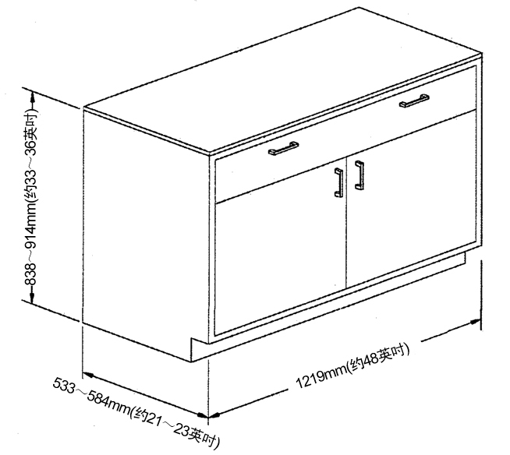
4.1 附图：检测单元外型
Fig. 4.1 Exterior of Detection Unit
检测柜体应为独自站立式，方形水平，并用高度调整脚抬离地面25mm(约1英吋)。柜体台面板使用一块25mm(约1英吋)厚环氧树脂板，但是不需使用扣件、胶或其它方式将台面固定。台面突出底柜四周25mm(约1英吋)以内。
The square leveling detection cabinet shall be of an alone standing type and shall be elevated from the ground by the height adjusting feet by 25mm (about 1 inch). A 25mm (about 1 inch) -thick epoxy resin plate is applied for the table board panel of the cabinet, without the need of fastener, glue or other ways to secure the table board. The table board protrudes out of the periphery of the base board within 25mm (about 1 inch).
于实施检测之前，必须先以目视检查柜体各部以确认是否完好。将门及抽屉操作一下，门应能自由开闭，门闩应在正确位置。检查尺寸大小是否符合规定并检查门及抽屉是否能与柜体密合，开关抽屉及门以检查是否能运作顺畅，功能是否正常。如果发现有任何不正常的情况时，应立即停止检测工作。
Before detection, all parts of the cabinet must be visually inspected to confirm whether they are in good condition. The door shall be opened/closed freely and the latch shall be at the proper place by operating the door and drawer. It is needed to inspect whether dimensions are in line with the provisions and the door and drawer are closely connected with the cabinet, whether the switch drawer and door operate smoothly, and whether the function is in good condition. In case of any improper condition, detection shall be stopped at once.
2 柜体整体荷重性能检测
2 Detection of integrated load performance for cabinet
检测目的：
Detection purpose:
柜体荷重检测将会对于柜体结构的完整性及荷重性作验证，本检测将会证明柜体对于其承受负荷能力，而不是去检测柜体在荷重负载的状况下之功能特质。
Load detection for cabinet will verify the completeness and load performance of cabinet structure. The detection will prove the load bearing capacity of the cabinet, instead of detecting the functions of cabinet under the load.
检测程序：
Detection procedure:
确认柜体为水平，并仅依靠调整脚支撑。使用固体重物(如铁条或钢板等)做为检测工具。将总重907公斤(约2000磅)之重物均匀置于柜体顶部台面上，排列方式如4.2附图，10分钟后将负载移除。台面板的重量计入荷重检测重量。
Confirm that the cabinet is horizontal and only rely on the adjustable feet for support. Use solid heavy object (such as bar iron or steel plate) as the detection tool. Place the heavy object with the total weight of 907kg (around 2,000 lbs) uniformly on the top of cabinet. See Fig. 4.2 for the arrangement. Remove the load after ten minutes. The weight of deck plate is counted into the load detection weight.
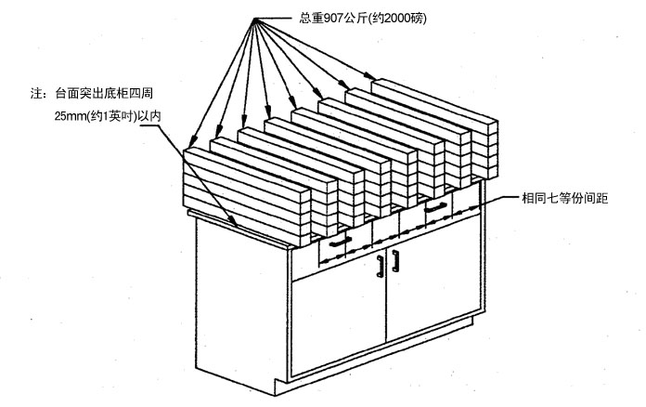

4.2 附图：柜体荷重检测
Fig. 4.2 Load Detection of Cabinet
合格标准：
Eligibility criteria:
柜体经十分钟的检测时间须能保持稳定支撑，不得因负重而产生任何永久性故障。在负重移除后，检查调整脚，如有任何的变形情况产生，都将会影响水平调整系统之正常功能。
After ten minutes of detection, the cabinet must remain stable for supporting and shall be free of any permanent fault due to the load. Check adjustable feet after removing the load. In the case of any deformation, it will affect the normal functions of horizontal adjustment system.
3 柜体集中荷重性能检测
3 Detection of concentrated load performance for cabinet
检测目的：
Detection purpose:
本检测之目的为对于当柜体的荷重集中在柜体上方中央时其功能特质的验证。
It is to verify functions when the load of cabinet is concentrated on the top center of the cabinet.
检测程序：
Detection procedure:
确认柜体为水平，使用固体重物(如铁条或钢板等)做为检测工具。将总重90公斤(约200磅)之重物置放于柜体的中心线(详见4.3附图)，然后操作门及抽屉。
Confirm that the cabinet is horizontal and use solid heavy object (such as bar iron or steel plate) as the detection tool. Place the heavy object with the total weight of 90kg (around 200 lbs) on the center line of cabinet (see Fig. 4.3 for details), then operate the door and drawer.
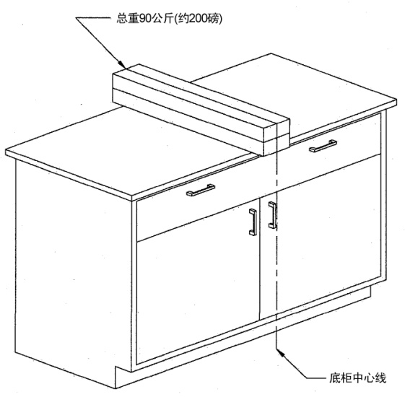

4.3 附图：柜体集中荷重检测
Fig. 4.3 Concentrated Load Detection of Cabinet
合格标准：
Eligibility criteria:
在有负载检测的情况下，门及抽屉应能正常的操作，而前横梁、柜体接缝处、门或抽屉都不得有永久性变形的迹象。
In the case of load detection, door and drawer shall be operated normally, while front beam, cabinet joint, door or drawer shall be free of permanent deformation.
4 门片性能检测
4 Performance detection of door leaf
门片及铰链荷重性能检测
Load performance detection of door leaf and hinge
检测目的：
Detection purpose:
本检测目的在检测门片及其五金(铰链活页、螺丝等)于加上90公斤(约200磅)负载后之强度。
It is to detect the strength of door leaf and hardware (hinge, screw etc.) after adding the load of 90kg (around 200 lbs).
检测程序：
Detection procedure:
检测前先取出底柜内的活动层板，底柜及台面的设置同4.1节所述。在台面上放置适当的重量以防止底柜于检测时倾倒。将门开至90度后，以两个各重45公斤(约100磅)的重物(砂袋或其它固体重物)用绳索悬吊于门片上两侧，悬吊位置应距铰链中心线304mm(约12英吋)处(详见4.4a及4.4b附图)。然后以8~10秒的速度慢慢地将门片由全关至全开的全行程操作一次，门的开度应至少开至160度，然后取下重物将门关闭，再以同样程序对另一片门进行检测。
Take out the movable laminate in the base cabinet before detection. The setting of base cabinet and table board is as described in Section 4.1. Place the object with proper weight on the table board to prevent the base cabinet from toppling during the detection. Hang one heavy object (sand pocket or other solid heavy object) with the weight of 45kg (around 100 lbs) on both sides of door leaf respectively, with the hanging position 304mm (around 12 inches) away from the center line of hinge (see Figs. 4.4a and 4.4b for details) after opening the door to 90°. Then slowly operate the door leaf from full closure to full openness at the speed of 8~10s, with the openness for the door of at least 160°, subsequently, remove the heavy object, close the door, and detect the other door in the same procedures.
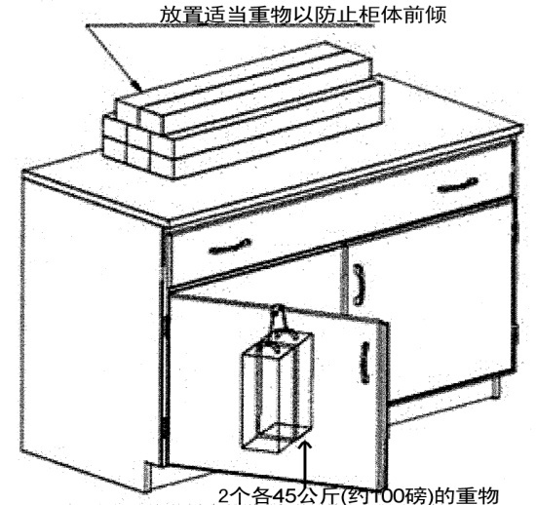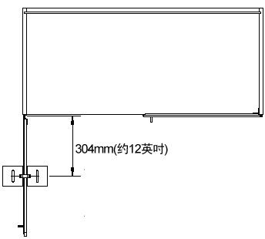
4.4a 附图：门片荷重检测结构  Fig. 4.4a Load Detection Structure of Door Leaf | 4.4b 附图：门片荷重检测结构  Fig. 4.4b Load Detection Structure of Door Leaf
合格标准：
Eligibility criteria:
当将负载加在距铰链中心线304mm(约12英吋)处时，门片应能承受90公斤(约200磅)的重量，而在荷重检测时，门的整个开关行程应能顺畅无阻碍，当移除负载后除应检查是否有永久性变形外，亦应检查整个门的开关行程是否因为承受重量而受损。
When the load is applied at the center line 304mm (around 12 inches) of hinge, the door leaf shall bear the weight of 90kg (around 200 lbs). However, during the load detection, the whole process of closure and openness of the door shall be smooth. After removing the load, it shall be detected if there is any permanent deformation, and if the door is damaged due to the weight bearing during the whole process of closure and openness.
5 抽屉性能检测
5 Performance detection of drawer
抽屉静态荷重性能检测
Static load performance detection of drawer
检测目的：
Detection purpose:
本检测的目的在检测当抽屉加上负载后抽屉滑轨及抽头与抽屉本体结合的强度。
It is to the strength of drawer slide and the drawer combined when the drawer is carried with load.
检测程序：
Detection procedure:
检测底柜及台面的设置同4.1节所述。在台面上放置适当的重量以防止底柜于检测倾斜。将抽屉打开至330mm(约13英吋)再将重68公斤(约150磅)的沙包或重物悬吊至抽屉的中心点或抽屉前端两侧处经五分钟检测后(详见4.5a或4.5b附图)，将重物移开后，将抽屉做全开及全关的动作。
Detect the setting of base cabinet and table board as described in Section 4.1. Place the object with proper weight on the table board to prevent the base cabinet from leaning during the detection. Open the drawer to 330mm (around 13 inches), hang sand pocket or heavy object with the weight of 68 kg (around 150 lbs) to both sides of central point or front end of drawer for 5-minute detection (see Figs. 4.5a or 4.5b for details), after this, remove the heavy object and fully close and open the drawer.
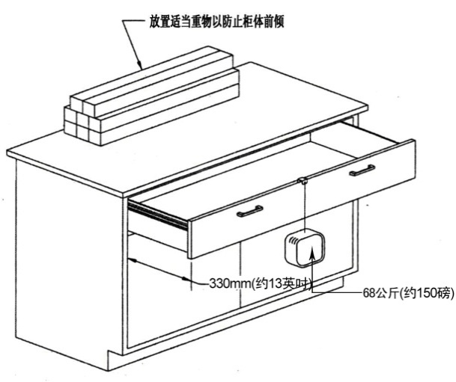
4.5a 附图：抽屉静态荷重检测
Fig. 4.5a Static Load Detection of Drawer
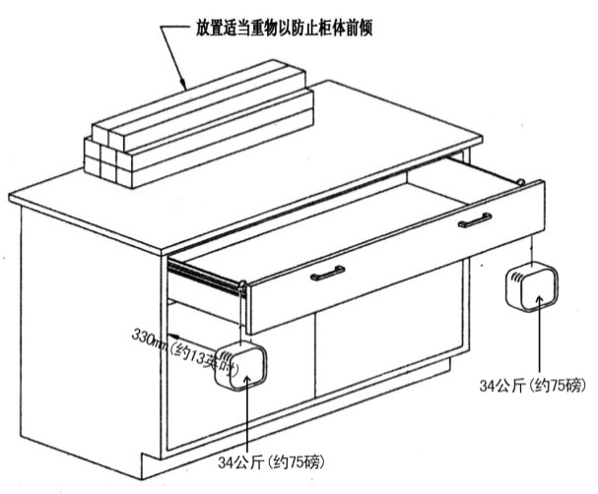
4.5b 附图：抽屉静态荷重检测
Fig. 4.5b Static Load Detection of Drawer
合格标准：
Eligibility criteria:
在检测后，柜体结构不应有永久性故障或影响抽屉开关的变形，并且抽屉在整个正常开关操作过程中不可有任何的阻碍。
After detection, the cabinet structure shall be free of permanent fault or deformation affecting closing and opening the drawer, and there shall be no any obstacle when closing and opening the drawer during the whole process.
6 层板荷重性能检测
6 Load performance detection of laminate
所有类型的层板均应依照下列程序检测，本检测也适用于试剂柜等高柜内部的层板。层板的材质应为冷轧钢板，通常外观厚度为19mm(约3/4英吋)或25mm(约1英吋)。
All types of laminates shall be detected according to following procedures. This detection is also applicable to internal laminates of tall cabinets, including reagent cabinets. Laminate shall be cold-rolled steel sheet with the thickness of the appearance of 19mm (around 3/4 inch) or 25mm (around 1 inch).
层板负载检测
Load detection of laminate
检测目的：
Detection purpose:
本检测的目的在检测层板及其安装五金于正常的实验室负载下的荷重能力。
It is to detect the load capacity of laminate and hardware installed under the normal laboratory load.
检测程序：
Detection procedure:
层板依其设计方式安装，量测层板底部至层板垂直中心的距离并纪录后，使用重物(砂袋或其它固体重物)做为检测工具。将层板以平均每929平方厘米(约1平方英呎)最多18.14公斤(约40磅)方式加负载直到总负载至高达到90公斤(约200磅)(即于层板平均划分成六格后于每格中心置放重物)(详见4.6附图)。以原先同样的方式及位置测量层板的弯曲程度，并计算两个测量值的差，记录测量值及差并将负载移除。
Install laminates according to the design pattern, measure and record the distance from the bottom of laminate to the vertical center of laminate, then use heavy object (sand pocket or other solid heavy objects) as detection tool. Exert the load of 18.14kg (around 40 lbs) at most for every 929 cm² (around 1 ft²) on the laminate until the total load amounting to 90kg (around 200 lbs) (namely after the laminate is divided into 6 grids averagely, place the heavy object at the center of each grid) (see Fig. 4.6 for details). Measure the curvature of laminates in the same original pattern and at the same position, calculate the difference of two measured values, record the measured value and difference, and remove the load.
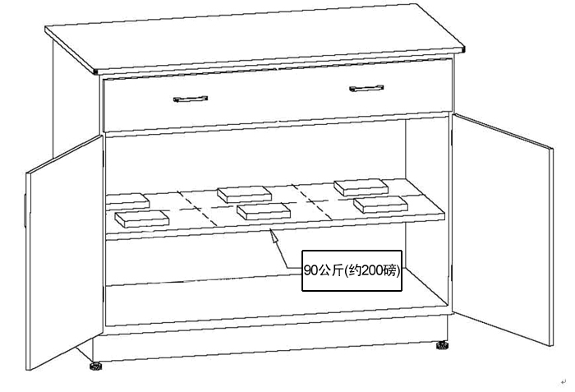
4.6 附图：层板负载检测
Fig. 4.6 Load Detection of Laminate
合格标准：
Eligibility criteria:
经五分钟检测时间须能保持稳定支撑不墬落毁损，且其下垂幅度不得大于6mm(约1/4英吋)，而当去除重物后，除应检查是否有永久性的伤害外，还应检查是否导致柜体结构变形或影响门或抽屉的开关。
After five minutes of detection, it must remain stable for supporting without falling, and the sag amplitude shall be no greater than 6mm (around 1/4 inch), while after removing the heavy object, it shall be detected if there is any permanent damage, and if the cabinet structure is deformed or closure and openness of door or drawer are affected.
框架式底座性能检测：
Performance detection of frame type base:
1 检测单元
1 Detection unit
检测的底座应是一张四腿自立式桌子。尺寸应至少为宽1524mm(约60英吋)，高838~914mm(约33~36英吋)，以及深533mm(约21英吋)(及以上)。(详见5.1附图)。桌腿及侧围板的尺寸及构造应满足制造商的规范要求。桌上台面板使用一块25mm(约1英吋)厚环氧树脂板，但是不需使用扣件、胶或其它方式将台面固定。台面突出桌子顶部四周25mm(约1英吋)以内。框架式底座的样式及设计会多种多样。本样式仅为参考，投标人可按本项目实际投标产品样式提供，但其框架横梁跨度不能小于5.1附图所示，框架并应用高度调整脚抬离地面25mm(约1英吋)。尺寸误差允许范围：±2.5%。
Base detected shall a free-standing table with four legs. The size shall be 1,524mm (around 60 inches) in width, 838~914mm (around 33~36 inches) in height and 533mm (around 21 inches) (and above) in depth at least. (See Fig. 5.1 for details). The size and structure of table leg and side coaming shall meet the standards and requirements of the manufacturer. A 25mm (around 1 inch) -thick epoxy resin plate is applied for the table board panel, without the need of fastener, glue or other ways to secure the table board. The table board protrudes out of the periphery of the table top within 25mm (around 1 inch). Frame type bases are different in pattern and design. This pattern is only for reference. The bidder can provide the pattern according to actual bid products of the Project, but the beam span of frame shall be no small than that shown in Fig. 5.1, and the frame shall be lifted 25mm (around 1 inch) above the ground by using adjustable feet. Allowable size error range: ±2.5%.
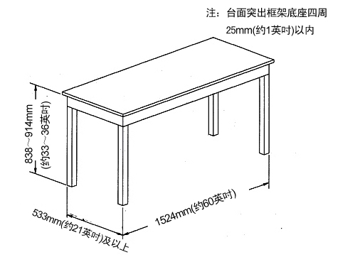
5.1 附图：检测单元外型
Fig. 5.1 Exterior of Detection Unit
框架整体荷重性能检测
Detection of integrated load performance for frame
1 检测目的
1 Detection purpose
本检测时为了考察底座零部件承受实验室用负载的能力。
It is intended to investigate the capacity of the base part to bear laboratory loads.
检测程序：
Detection procedure:
使用固体重物(如铁条或钢板等)做为检测工具。将总重272公斤(约600磅)之重物均匀分布置放于底座顶部施加负荷，如5.2附图所示。台面板的重量计入荷重检测重量。
Use solid heavy object (such as bar iron or steel plate) as the detection tool. Heavy objects with the total weight of 272kg (about 600 lbs) are uniformly placed on top of the base to apply loads, as shown in Fig. 5.2. The weight of deck plate is counted into the load detection weight.
注：重物距离台面边缘不超过75mm(约3英吋)，前后外悬量相等。
Note: The heavy object is not more than 75mm (about 3 inches) from the table edge, with the same front and rear overhanging.
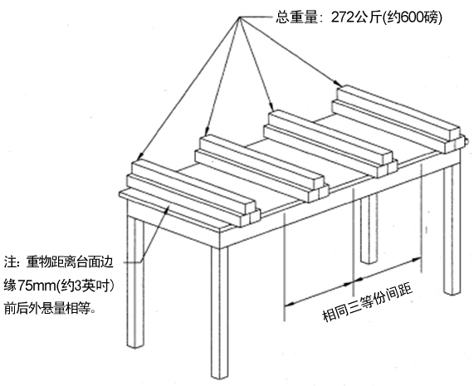
5.2 附图：底座荷重检测
Fig. 5.2 Base Load Detection
合格标准：
Eligibility criteria:
施加负载后应没有出现结构性破损。在全负载情况下，侧围横梁变形应不超过底座跨度的1/360且不大于3mm(约1/8英吋)。如果底座有抽屉，那么横梁的变形应不会干涉到抽屉的功能。在卸去负载后，检查底座有无结构性损坏。
After applying loads, there is no structural breakage. Under the full load, the side wall beam deformation shall not exceed 1/360 of the base span and not be more than 3mm (about 1/8 inch). If the base has a drawer, the deformation of the beam shall not affect the function of the drawer. After load removal, inspect whether the base is structurally damaged or not.
五、 主要材料设备推荐品牌表
V. Recommended Brands of Main materials & Equipment
1. 本《主要材料设备品牌响应表》中的品牌供投标人在编制投标文件时参考，投标人应予积极响应。投标人如需提供其他品牌，至少需提供推荐品牌同等档次或以上的品牌。
2. 中标后承包厂商必须按其投标文件中选定的品牌交货、不得更换品牌。如因特殊原因需要更换品牌，必须经招标人同意，且必须在招标文件规定的参考品牌中选用。
2. After winning the bid, the Contractor must deliver goods according to the brand selected in the bid document, but shall not change the brand. If it is necessary to change the brand for special causes, the Contractor must select from the reference brands specified in the bidding document with consent of the bid inviter.
编号  No. | 名称  Name | 推荐品牌  Recommended brand
一  I | 实验室家具部分  Laboratory furniture
1 | 台面  Table board | 1.Trespa(千思板)；2.威盛亚；3. 都抗  1. Trespa; 2. Wilsonart; 3. Durcon
2 | 钢结构材料  Steel structure material | 宝钢、鞍钢、武钢一级冷轧钢板；  Baosteel, Ansteel, Wusteel high grade cold-rolled steel sheet;
3 | 实验室专用水龙头  Special tap for laboratory | 1.Broen；2.Far； 3.Watersaver
4 | 桌上洗眼器、紧急喷淋  Desktop eye bath, emergency shower | 1.Broen；2.Watersaver； 3.Far
5 | 万向抽风罩  Universal draught hood | 2. FUMEX 3.Alsident；4.Nedermann；
6 | 电源插座  Power socket | 1.施耐德；2.西门子；3.ABB  1. Schneider; 2. Siemens; 3. ABB
7 | 水槽、滴水架  Sink, drip rack | 1.SAN 2.BRLON 3.TOF  1. SAN 2. BRLON 3. TOF
8 | 滑轨、合页或铰链  Sliding rail, hinge | 1.海福乐 2.格拉斯 3.金丝莱德  1. Hafele 2. Grass 3. Kingslide
9 | 实验台柜钢材表面环氧树脂粉末  Epoxy resin powder on the steel surface of laboratory bench | 1.Dupont 2.阿克苏诺贝尔 3.佐敦  1. Dupont 2. Akzo Nobel 3. Jotun
10 | 热水器 | 1.A.O.史密斯；2.美的；3.海尔

防火柜产品要求：
- 产品通过EN 14470-1（化学品防火柜），EN 14470-2（化学品气瓶防火柜）；；CE 、NFPA、FM，EPA，OSHA认证； 柜体防火等级≥90分钟；
- 具备柜体锚定，防倾倒； (台下柜及防火柜不需要该项目)
- 防静电积蓄，可达到静电释放导除功能；
安装后需厂家提供第三方静电释放检测报告；（接入消防实验室静电接地铜排或等电位线的，不需要进行此项目）
- 防冲击；防尘，防锈和防潮；
- 双开门，左右可独立存放存在化学禁忌但适合隔离储存的化学品；
(为节约空间，控制实验室储存量，但又考虑实际操作需求，如有可能可考虑同柜但可达到完全隔离储存效果来储存必须隔离存放的物品，例如：腐蚀、有毒化学品)；
- 柜身应具备双锁功能；
- 层板4-6层，且防止泄漏的液体外溢，符合盛漏规范，如抽屉式托盘架；
- 具备废气排放功能，安装相应的管线至废气排放系统，每个柜子的废气需加装手动排气控制阀；
（管线必须考虑防静电/防爆型，提供相应的安装检测报告，确定连接有效性，目前接入学校排气系统则无需提供相关排风证明）
- 针对防火柜供货商要求：
- 须提供防火柜厂家对广以此项目防火柜要求和产品型号的针对性说明；
- 厂家对代理商的授权书；
- 产品原产地证明；
- 进口报关单等相关设备进口手续证明(如果是进口产品)；
- 以及相关标准测试报告；（需到货时提供厂家产品合格报告；）

备注：红色内容为必须提供项目

推荐品牌：
- Duperthal
- Asecos
- SYSBEL

